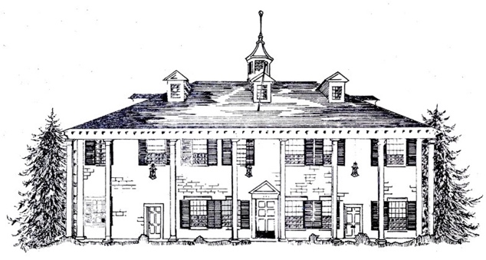

Rainier Chapter
National Society,
Daughters of the American Revolution
800 East Roy Street – Seattle, WA 98102 – (206) 323-0600
darrainier@comcast.net - www.rainierNSDAR.org

RAINIER CHAPTER SCHOLARSHIP CHECKLIST AND APPLICATION
INSTRUCTIONS: Mail the completed application packet to the Rainier Chapter Scholarship Committee. The application packet must be complete and arranged in the order listed below. All transcripts, letters of recommendation and other required documents must be sent in a single package to the Rainier Chapter chair postmarked no later than February 15th. The chapter will accept those postmarked on February 16th in the event that February 15th falls on a Sunday or a holiday. Nothing will be returned to the applicant. Photographs will result in disqualification and should not be included. Scholarships are judged and awarded on the merits of the application, without regard to gender, race, color, religion, national origin or disability. The amount of the scholarship and the number of worthy recipients will be determined by the Rainier Chapter, NSDAR. Scholarships will be announced at the regular meeting in June (second Tuesday) and recipients must attend the June meeting. Funds will be distributed directly to the college or university of acceptance. Incomplete applications will not be considered.
CHECKLIST:
- This completed form
- Essay of 700 words or less on one of the following topics:
  - the importance of promoting patriotism
  - preserving American history
  - securing America’s future through better education
  - the importance of service and how you contribute to your community
- High school transcripts
- Two letters of recommendation, at least one from a teacher
- List in order: a) extra-curricular school activities b) community activities, including the number of years of participation in both, c) any honors received and d) scholastic achievements
Name of Student E-mail Phone
Permanent address City State Zip Code
High school School district County

Include the complete address for the college/university to receive and credit the funds awarded
Name of college/university Identification #

Address City State Zip Code
Family members who were/are members of DAR (This is NOT a requirement to be awarded a scholarship)
Name(s) of DAR member(s) Relationship to applicant National number

In submitting this application, I certify that I am a citizen of the United States of America, and that the information provided in this application is complete and accurate to the best of my knowledge. I have read and understand the scholarship eligibility requirements. False information submitted as part of this application will result in the revocation of any scholarship granted.
Student Signature: _________________________________________________ Date: _______________

